Öltések , Vbodi, Stiche, Stiches:
1. | ANG | SLO | DE | HU
 | running stich | prednji vbod | der Vorstich | futóöltés

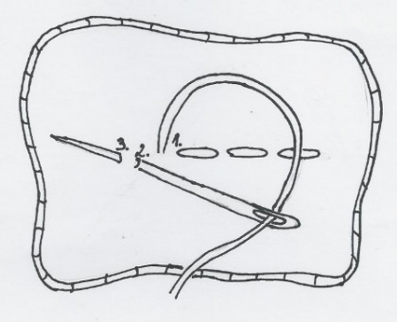 | 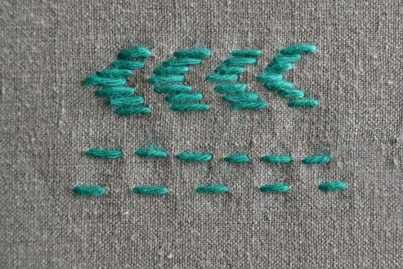
1 | 2 | 3
1. https://ucilnice.arnes.si/mod/resource/view.php?id=1135505
2. https://pumora.de/stickstiche-zum-nachsticken-sticktutorials/
3. https://www.thesprucecrafts.com/working-the-running-stitch-1177571

2. | ANG | SLO | DE | HU
 | back stich | zadnji vbod | der Rückstich | fonáköltés

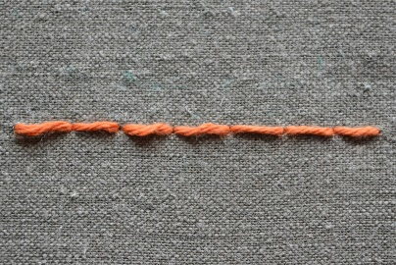
1 |  |  | 2
1. https://pumora.de/stickstiche-zum-nachsticken-sticktutorials/
2. https://www.thesprucecrafts.com/working-the-running-stitch-1177571

3. | ANG | SLO |  | DE | HU
 | satin stich | ploščati vbod |  | der Plattstich | ferde gobelinöltés

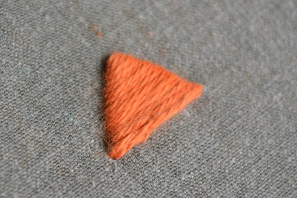
1 |  |  | 2
1. https://pumora.de/stickstiche-zum-nachsticken-sticktutorials/
2. https://www.thesprucecrafts.com/working-the-running-stitch-1177571

4. | ANG | SLO |  | DE | HU
 | stem stich | verižni vbod |  | der Stielstich | alapszál öltés

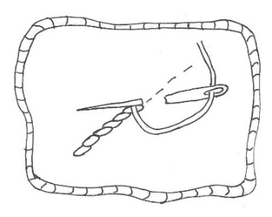 |  |  | 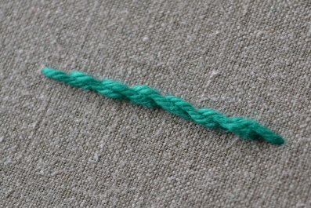 |  | 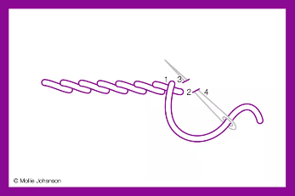
1 |  |  | 2 |  | 3
1. https://ucilnice.arnes.si/mod/resource/view.php?id=1135505
2. https://pumora.de/stickstiche-zum-nachsticken-sticktutorials/
3. https://www.thesprucecrafts.com/working-the-running-stitch-1177571

5. | ANG | SLO |  | DE |  | HU
 | chain stich | verižni vbod |  | der Kettenstich |  | láncöltés

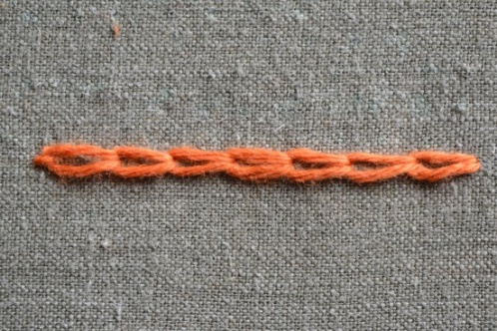
1 |  |  | 2
1. https://pumora.de/stickstiche-zum-nachsticken-sticktutorials/
2. https://www.thesprucecrafts.com/working-the-running-stitch-1177571

6. | ANG | SLO | DE | HU
 | Daisy stich | marjetični vbod | der Margeritenstich | százszorszép öltés

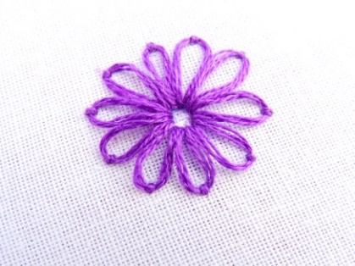 | 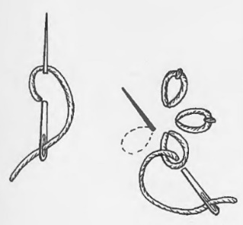
1 | 2
1. https://www.wanderingthreadsembroidery.com/lazy-daisy-embroidery-stitch-tutorial/
2. https://www.brigitte.de/leben/wohnen/selbermachen/sticken/sticken-lernen--der-margeritenstich-10164900.html

7. | ANG | SLO | DE | HU
 | french knot | vozličasti vbod | der Knötchenstich | francia csomó

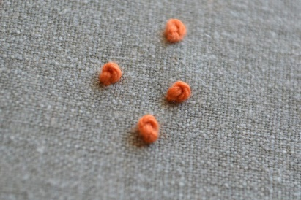
https://pumora.de/stickstiche-zum-nachsticken-sticktutorials/

8. | ANG | SLO | DE |  | HU
 | fishbone stich | vbod ribja kost | der Grätenstich | halszálka öltés

https://www.pinterest.de/pin/424393964885955756/

9. | ANG | SLO | DE | HU
 | cross stich | križni vbod | der Kreuzstich | keresztöltés

https://pintangle.com/2015/08/03/alternating-cross-stitch/alternatingcross-4/

10. | ANG | SLO | DE |  | HU
 | Long and short satin stich | slikarski vbod | versetzter Plattstich | hosszú és rövid szatén öltés

Image by @naive_needle
